# Blowdown

$$p_{tank}=475000 Pa, T_{sat}={150}^{o}C, V_{tank}=3.0 m^{3}, V_{water, i}=2.0 m^{3}, D_{orifice}=.0504 m, E=2.2*{10}^{9} Pa, c_{0}=.00418\frac{J}{kgK}, λ=2.230\frac{J}{kg}$$

$$G=ρ_{tank}λ{\left(T_{0}c_{0}\right)}^{-\frac{1}{2}}$$

$$ρ_{tank}=\frac{ρ_{water}}{1-\frac{p_{new}-p_{old}}{E}}$$

$$V_{new}=V_{old}-G*\left(π{\left(\frac{D_{orifice}}{2}\right)}^{2}\right)*t$$

$$p_{new}=\frac{p_{tank}V_{tank}}{V_{new}}$$

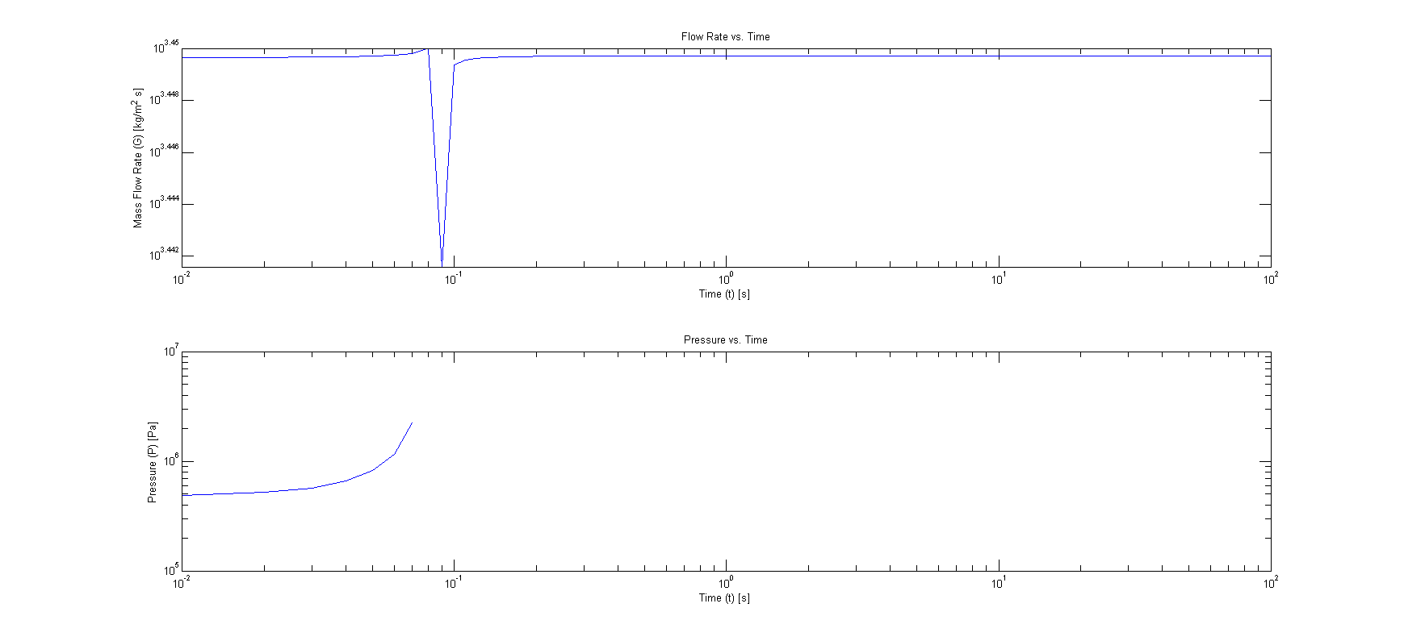

# Works Cited

Incropera, DeWitt, Bergman, & Lavine. *Fundamentals of Heat and Mass Transfer* (6 ed.). Wiley.